**Amar Gajanan Mohite**

Section – IFT562

**Arizona State University**

Instructor**:** Daniel Wells

**Assignment 1- AWS Resource Setup**

Date – 11/01/2024

Screenshot 1 – Access to the course

Screenshot 2- Module 1 Knowledge check

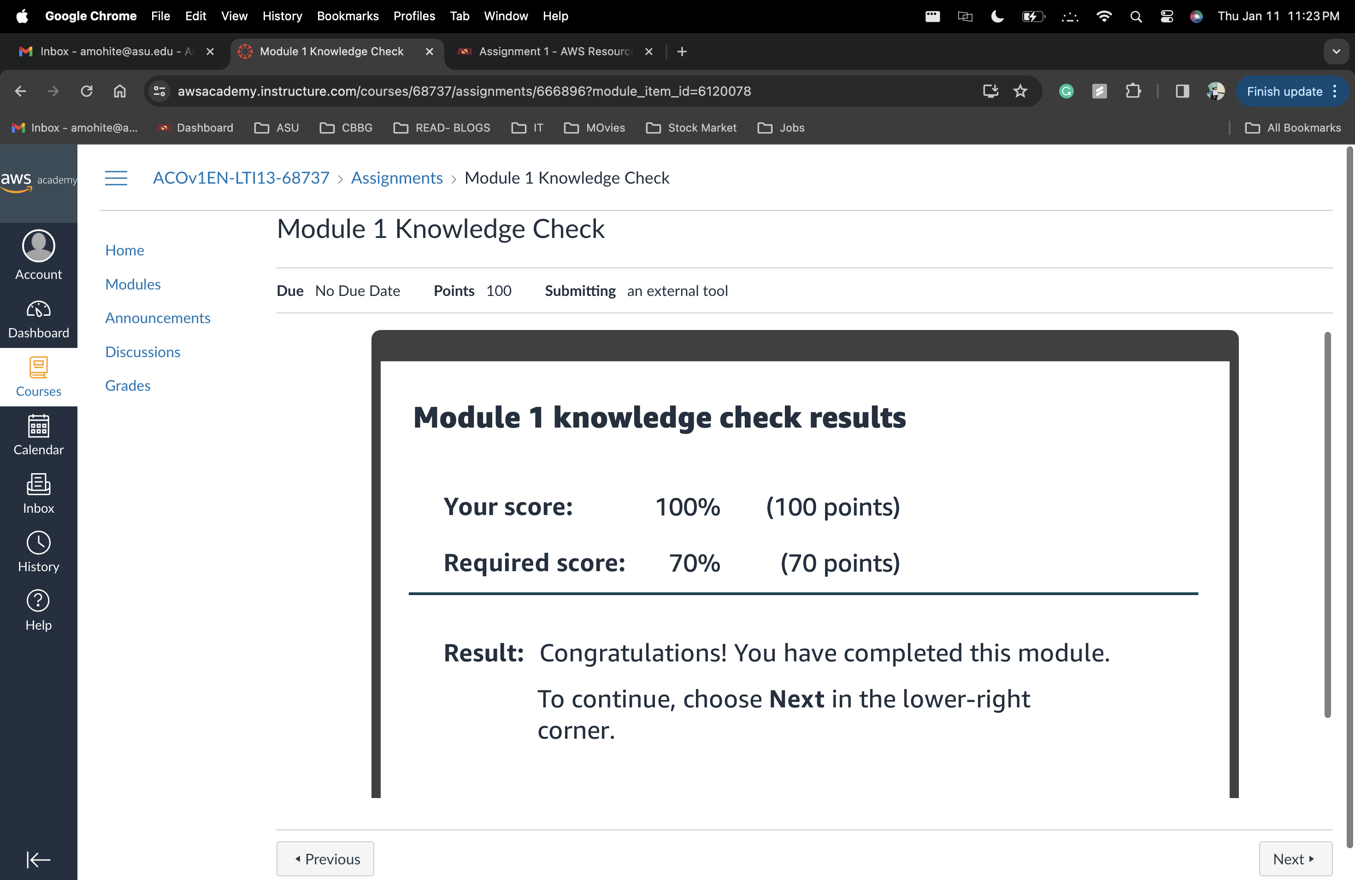

Screenshot 3- Module 2 Knowledge check

